6A^{th} Grade: Unit 6, Lesson 1

- An expression is shown.
$$3^{5}$$
In the expression, the 3 is the ___________ and the 5 is the ______________.

Base; exponent

- Write an exponential expression that represents $5×5×5×5×5×5$.

$$5^{6}$$

- Four expressions are shown.
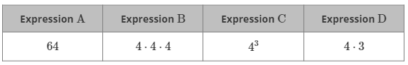
Which expression does not have the same value as the others?

Expression D

